Report Td1-2-3
  - Maximilien BERNARD

TD 1
Git Clone my branch
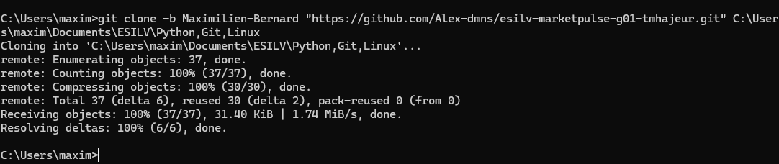
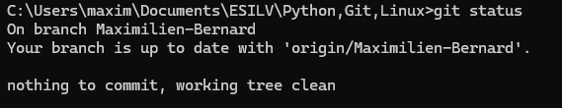
Part 5
5.1
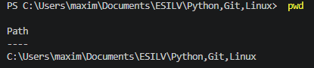
5.2
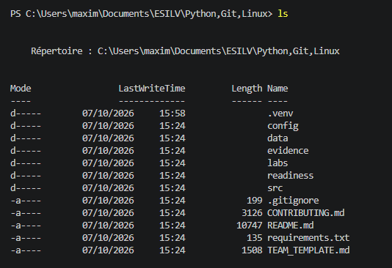
5.3
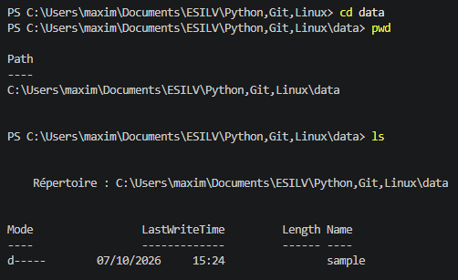
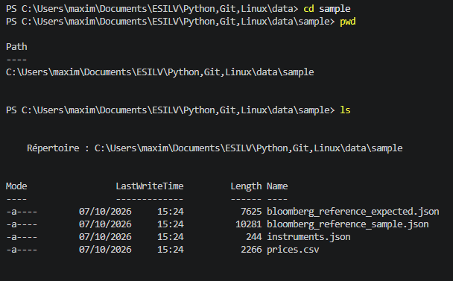
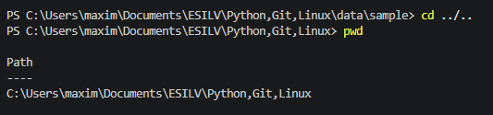
Part 6
6.1
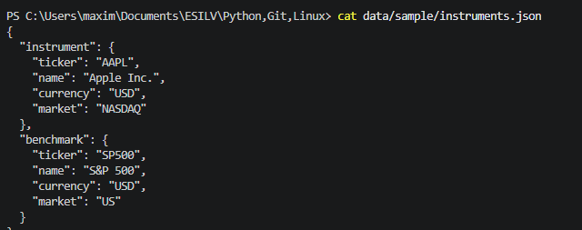
6.2
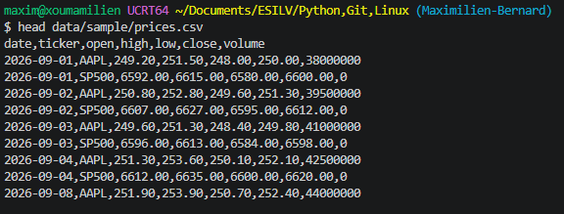
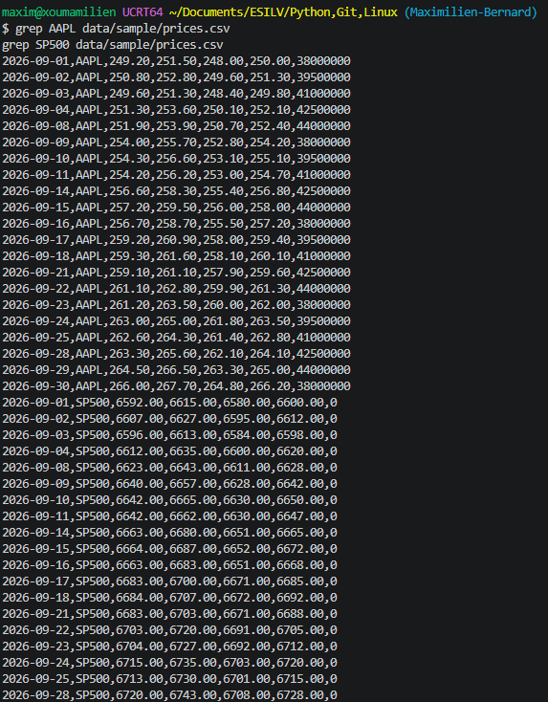
Part 7
7.1
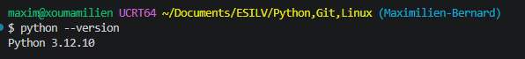
7.2
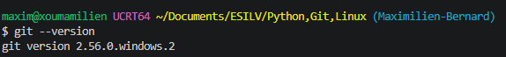
7.3 Run MarketPulse
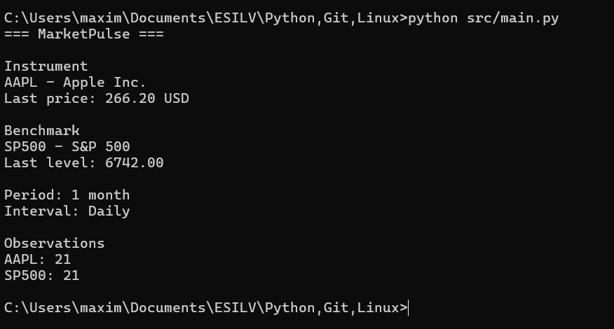
Optional 1
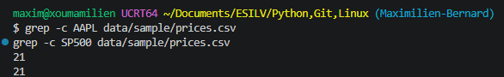

Optional 2
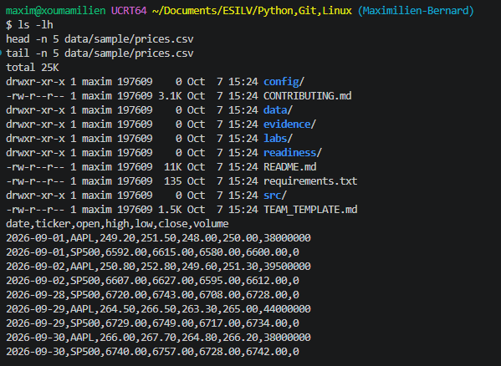
Head affiche les 5 premières lignes du csv alors que tail affiche les 5 dernières lignes du csv

Optional 3
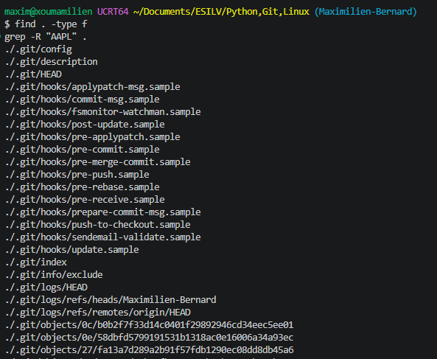

Optional 4
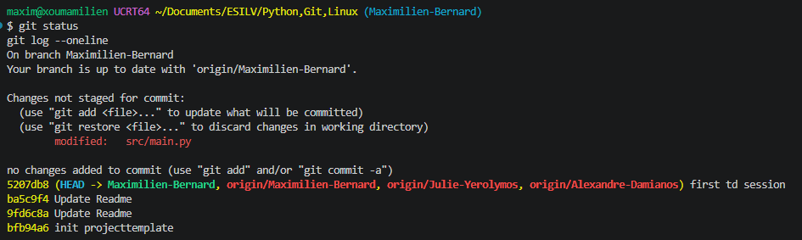
TD 2
Part 2
Inspect cat data/sample/instruments.json
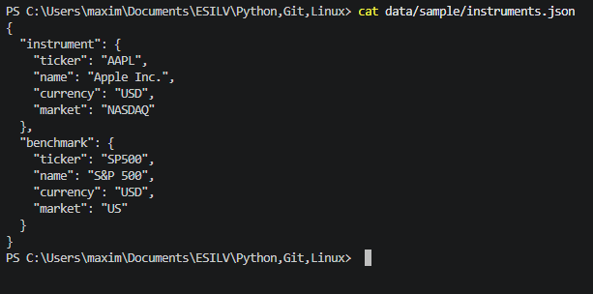

Temporarily inspect the result:
print(type(instruments))
print(instruments.keys())
Then inspect nested dictionaries:
instrument = instruments["instrument"]
benchmark = instruments["benchmark"]

print(instrument["ticker"])
print(instrument["name"])
print(instrument["currency"])

print(benchmark["ticker"])
print(benchmark["name"])
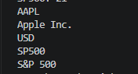
Part 3
Temporarily inspect:
prices = load_prices()

print(type(prices))
print(type(prices[0]))
print(prices[0])
Inspect:
print(prices[0]["close"])
print(type(prices[0]["close"]))

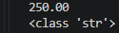
Convert when a numerical value is needed:
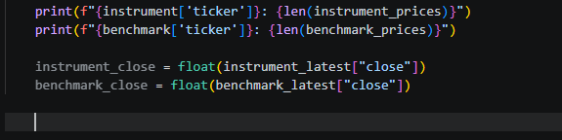
Part 4
Part 5
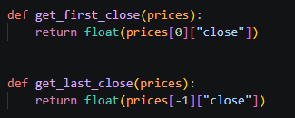
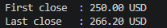
Part 6
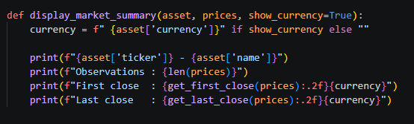
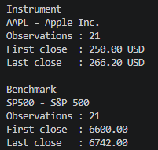
Part 8
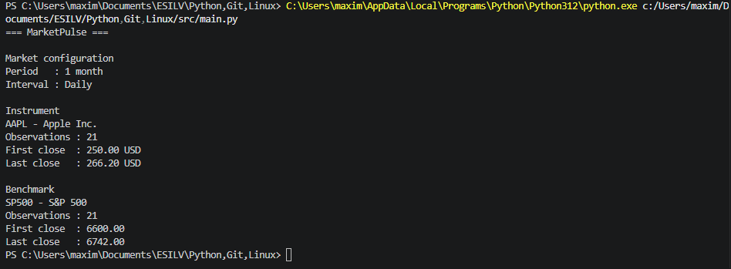

FOR Part 9-10, full code pushed in GitHub Branch

